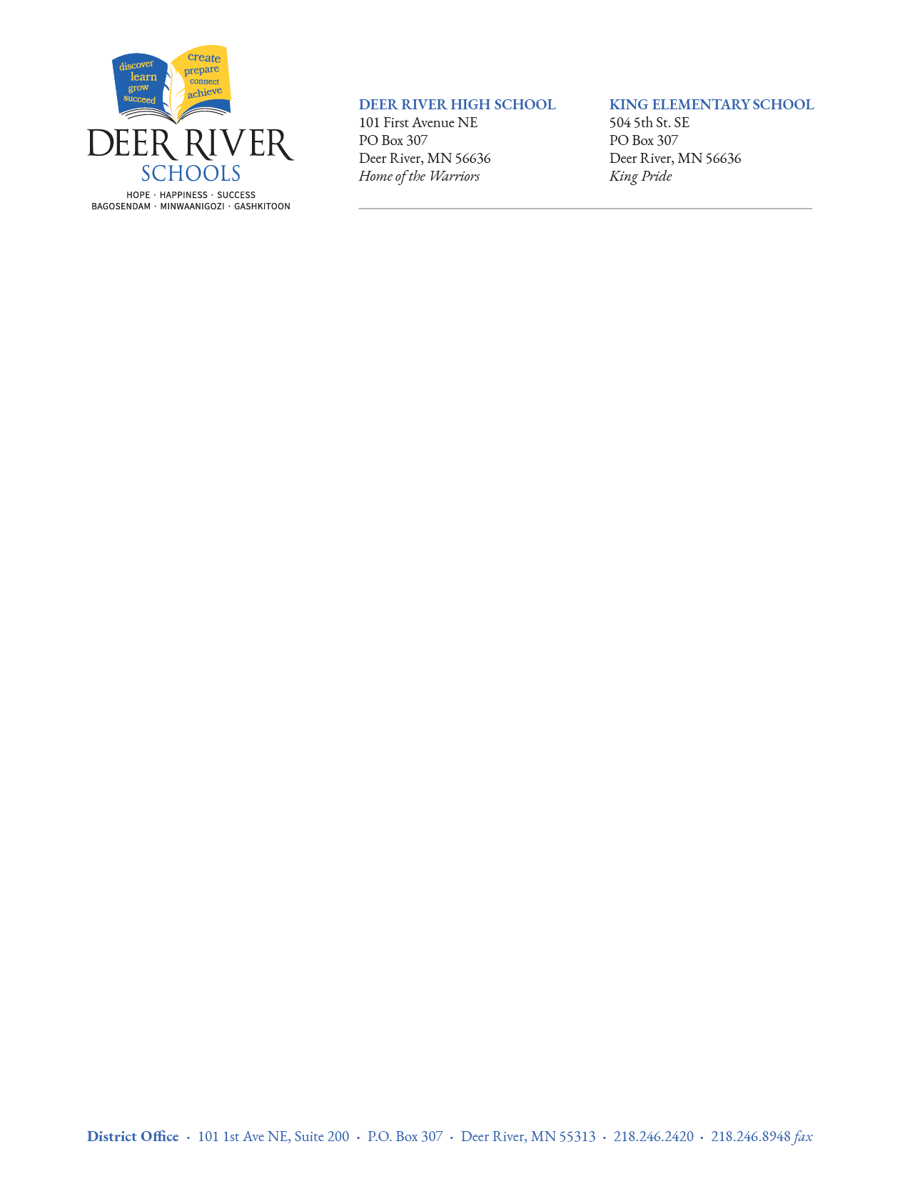
Board of Education Priority Goals For 2021-2022

- Maintain a safe and productive learning environment.

- Keep King Elementary School and King Learning Center open daily if possible.

- Keep Deer River High School open daily if possible and adapt as necessary to shift
resources to keep King open.

- Cancel or postpone any non-essential activities that are likely to interfere with goals 1-3.

