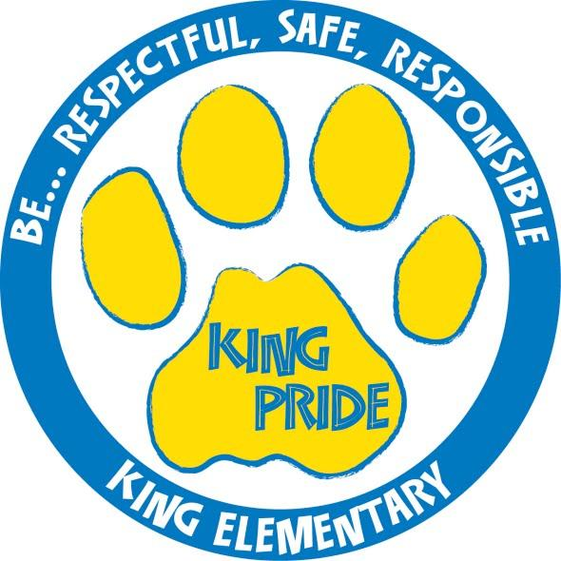

King Elementary School

Student Handbook
2021-2022

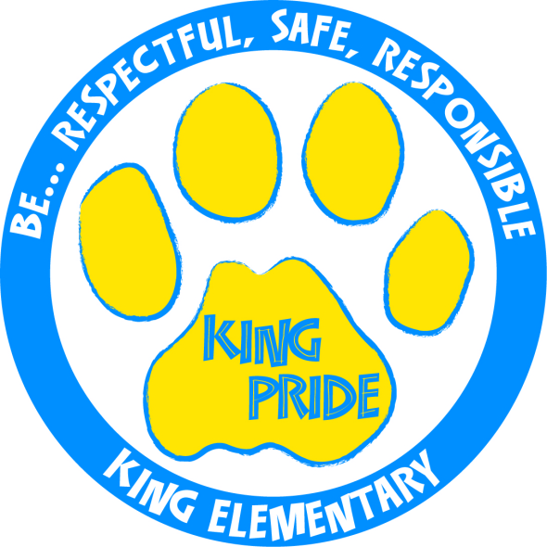

Dear Students, Parents, and Guardians:

Welcome to King Elementary School! It is with great pleasure that we have this opportunity to provide educational services for your most prized possession, your child. Deer River Schools has a strong reputation for high quality programs. The staff at King Elementary School is dedicated to high student achievement, creating positive school culture, and active community engagement in order to enhance the educational experience for our students.

King Elementary qualifies for school-wide Title 1 funds. We are committed to being partners in your child’s education. Please refer to the compact on the following page that outlines our pledge to work together. This compact is an important commitment that we hold together to support your child.
King Elementary works to ensure that ALL students are successful by promoting “King Pride” among the King School community. We ask all students to show “King Pride” each day by:
Being Respectful, Being Responsible and Being Safe
In order to teach students expected behavior, the staff of King School created a matrix that outlines what behavior should look like in all settings of King School: classroom, hallway, bus, cafeteria, restroom, lockers, digital citizenship, and playground. We have added the matrix to the handbook for you to review with your child.
We look forward to working closely with you in the future and encourage you to become an active part of King Elementary. If you have questions at any time regarding your child’s education, please don’t hesitate to contact the school.
Sincerely,

King Elementary School Staff

Independent School District 317
Schoolwide Home / School Compact
King Elementary School

LEARNING—A TEAM APPROACH: This compact is a pledge to work together. We believe that this can be fulfilled by a team effort. Together we can improve teaching and learning. We are asking all parents and teachers to review this compact with their child(ren). If you have any questions or wish to abstain from the compact, please contact your child’s teacher.

STUDENT AGREEMENT: As a student I pledge to:
Attend school regularly and on time.
Have a positive attitude towards myself, others, school and learning.
Know and follow all school and class rules.
Be respectful to my classmates and the adults that help me learn.
Ask for help and ask questions when I don’t understand.
Work as hard as I can and complete all assignments on time.
Limit my screen time and do quiet learning activities instead.
Discuss with my parents what I am learning at school.

PARENT/GUARDIAN AGREEMENT: As a parent/guardian I pledge to:
See that my child attends school regularly and on time.
Support the school in it’s efforts to maintain proper discipline
Establish a quiet study time and encourage good study habits.
Encourage my child’s efforts and be available for questions.
Stay aware of what my child is learning.
Find out how my child is progressing in the school program by attending conferences.
Respond to communications sent home
Limit screen time and encourage quiet reading and activities instead.
Provide 15-20 minutes a day reading to/with my child.

TEACHER AGREEMENT: As a teacher I pledge to:
Respect, love, and encourage children, their ideas, and their growth.
Find techniques and materials that work best for each student.
Vary techniques, materials, and pace of outcomes by focusing on achievement.
Be available to explain or answer questions about the school program.
Provide necessary assistance to parents so their children can become successful learners.
Communicate regularly with parents and students regarding progress in learning and behavior.

PRINCIPAL AGREEMENT: As a principal I pledge to:
Create a welcoming environment for students and parents.
Communicate the school’s mission and goals to students and parents.
Maintain a positive learning environment.
Reinforce the partnership between families, students, and staff members.
Provide appropriate in-service and training for staff members and parents.
Maintain and foster high standards of academic achievement and behavior.

King Pride
Research has shown that when students feel safe and supported at school they will demonstrate increased student achievement. Our ultimate goal is to create a safe and welcoming school environment by promoting KING PRIDE. This matrix was created to teach students expected behavior in all settings of King School. Please take time to review this with your child. King School staff refers to this matrix throughout the school day as we teach desired expectations for all students. We are proud to announce that King Elementary continues to be recognized as an Exemplar PBIS school since 2015 from the Minnesota Department of Education.

School-Wide Recognition Plan
The purpose of the school-wide recognition plan is to acknowledge and show appreciation to students who have provided positive demonstrations of King Pride.

Name | Criteria | Award | Presented | Frequency | Coordinated by
Pride Paw | Following behavior expectations on matrix (i.e. showing King Pride) | Pride Paw  Specific verbal praise | Anywhere King Pride can be observed | Daily  Staff should distribute 2-3 paws per day | PBIS team and office
King Pride “Shout Out” | Students who go above and beyond to model King Pride | Specific public praise | School Announcements | Several times each quarter | Office and staff
Student of the week | Earned a pride paw during the previous week | Certificate and  small prize | School announcements | Weekly | Office
Staff of the week | Earned a pride paw during the previous week | Certificate  Small gift | School announcements | Weekly | Office
Student  Assistant Principal | A 5th grade student who has demonstrated hard work ethic, being conscientious about school work and giving his/her best effort | Certificate  School bag  Help with morning announcements  Eat lunch with principal in the principal’s chair | During 5th grade team time  School announcements | Weekly | 5th grade teachers
Cyrus King Citizenship Award | Provided to those who consistently show King Pride and are role models for others | Certificate and letter to parents  Picture posted by school on electronic media and in display case | All-school assembly | Quarterly | PBIS team
Amazing Attendance Award | Students who attend school every day and are on time | Certificate | Classroom  Group recognition during assembly | Quarterly | Truancy Prevention Specialist (TPS) and office
Classroom Attendance Award | The class with the best classroom attendance rate each quarter | Certificate and Classroom pizza party or treat for class | All-school assembly | Quarterly | TPS and office
Improved behavior, attendance or academics | Students who have shown significant improvement | Certificate | Classroom or individually | Quarterly | PBIS Team and teachers

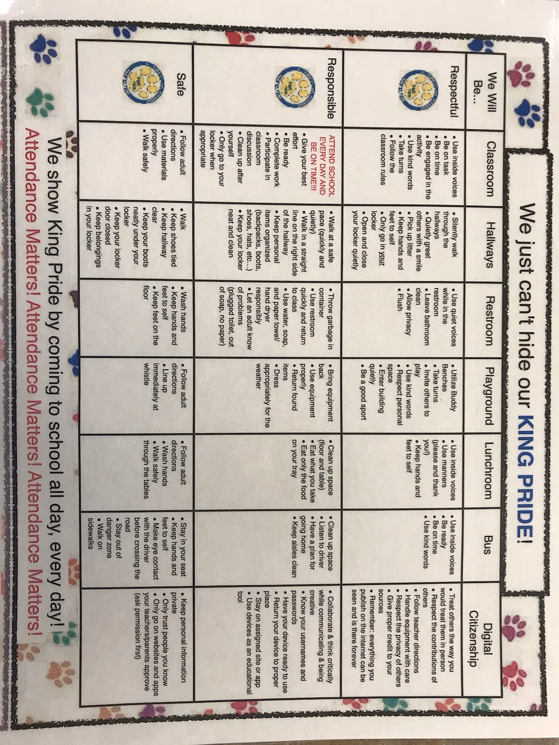

KING SCHOOL INFORMATION AND POLICIES

ACADEMICS:

All of the intermediate grades will use a similar rubric for sharing progress on grade level standards.

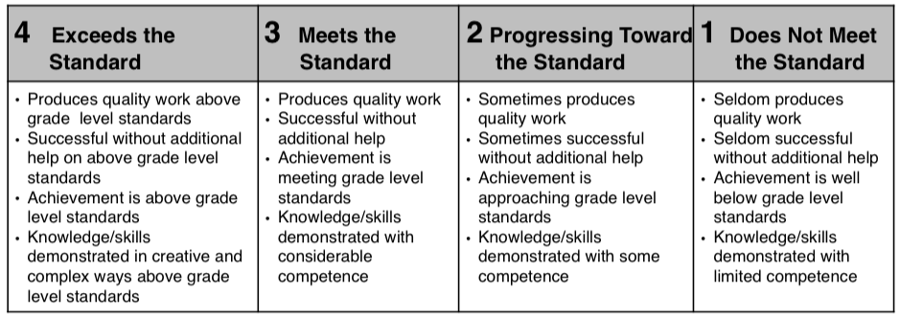

HOMEWORK:
Students are usually given study time during the school day to complete assignments. As the child progresses through the grades, the amount of homework gradually increases. The important factor is that the students take responsibility for their assignments, seeing that they are completed and handed in to the teacher. If it appears that your child has an excessive amount of homework to do, please contact his/her classroom teacher to express your concerns.

ACCIDENTS:
Every accident in the school building, on the school grounds, at practice sessions, or at an activity sponsored by the school must be reported immediately to the person in charge and to the principal.
FIRST AID/MEDICAL CARE:
The nurse’s office in each building is equipped to handle minor injuries requiring first aid. If the nurse’s office is not open, assistance can be sought from the building’s administrative office. If a student experiences a more serious medical emergency at school, 9-1-1 will be called and/or a parent/guardian will be contacted depending on the situation.

ARRIVAL:
If your child does not ride the bus, please time his or her arrival for after 8:00 AM. Supervision is provided from 8:00 - 8:25 AM when classes begin, allowing enough time for hanging up clothes and settling in.

RELEASE:
If you are picking up your child after school, please do so at the south lot pick up zone. If you are picking your child up early from school, you may enter the front parking lot up until 2:30 PM or 2:00 PM on Wednesday—after that time buses will be in the front lot. For your child’s safety, students are not allowed to walk, unaccompanied, to waiting vehicles until all buses have left the parking lot. Likewise, student walkers are not dismissed until all buses have left the parking lot. All students must be picked up by 3:00 PM

DROP OFF/PICK UP PROCEDURES:
The front parking lot will be open to buses ONLY from 7:45-8:30 and 2:30-3:10 (2:00 on Wednesdays). No cars will be allowed in this area during these times. All cars will drop-off/pick-up students through the south parking lot. Parents are asked to drop-off one car at a time at the door. Traffic will be asked to wait as students are dropped off and then move slowly towards the doors to drop-off your student. Children are not to exit the car until the car has entered the drop-off/pick-up zone.

ATTENDANCE POLICY:
Schools are responsible for teaching your child but we can’t do our job if your child is absent. A child who misses a day of school also misses a day of learning that might never be replaced. You can help by making school a top priority. By building the habit of daily attendance, you will help your child see that school is important. If your child will be absent or late from school, please call the attendance line (246-3403) before 9:00 AM explaining the reason for their absence.

On occasion, you may have to take your child out of class before the end of the school day. According to school policy, you must come to the office and sign out your child. No child will be released to parents directly from the classroom. Students will be called to the office for pick up. If someone other than the child’s parent will be picking up a student, the parent must contact the school to give permission.

Once a student enrolls at King Elementary School, they subject themselves to the following policies.

Excused Absences/Tardies
Parents must call the school attendance line (246-3403) by 9:00 AM on the morning their child is going to be absent. The following are examples of excused absences:

- A condition that requires ongoing treatment for a mental health diagnosis
- The death, serious illness, or funeral of the student’s immediate family or of a close friend or relative
- Child illness, medical, dental, orthodontic, or counseling appointment
- Court appearances occasioned by family or personal action
- Religious/cultural instruction not to exceed three hours in any week
- Physical emergency conditions such as fire, flood, storm, etc.
- Removal of a student pursuant to a suspension. Suspensions are to be handled as excused absences and students will be permitted to complete make-up work.
- Family emergencies
- Active duty in any military branch of the United States
- Family obligations/vacations with prior notification to the office. Families need to obtain a “Pre-Absence” form from the office for any absences where the student will miss 3 or more consecutive days.

Unexcused Absences/Tardies
Students who arrive to school after 8:25 AM are considered tardy. Students who arrive after 9:00 AM will be considered absent for that period. The following are examples of absences that will not be excused:
- Absences that are unreported
- Personal transportation problems
- Missing the school bus
- Shopping
- Oversleeping or overtired
- Skipping school or class
- Caring for siblings, family, or friends
- Truancy. An absence by a student which was not approved by the parent and/or the school district.
- Any absence in which the student failed to comply with any reporting requirements of the school district’s attendance procedures.
- Work at home or a business, except under a school-sponsored work release program

In an effort to be proactive in improving attendance, the school has the following procedures in place to support student attendance:
- After five (5) unexcused absences, administration may request a meeting with the family, the student, school representative, Truancy Prevention Specialist, and possibly county or tribal social services in order to identify barriers to good attendance and develop a plan to improve attendance.
- After seven (7) unexcused absences from school, a student is deemed truant and the school Truancy Prevention Specialist will take appropriate action.
- After a student accumulates eleven (11) excused or unexcused absences in a semester, the student and family may be required to attend a meeting with administration, develop an attendance contract, and/or be required to submit medical documentation for future absences in order to be excused.

Exempt Absences
The following absences are considered exempt absences and do not count towards overall total absence.
- In school suspension
- School activities
- Funeral for immediate family
- Medical absences or illness documented by doctor or school nurse
- Court appearances
- Official school field trip or other school sponsored outing
Students must provide documentation to the office. A note from a physician or a licensed mental health professional stating the child cannot attend school is a valid excuse.

ATTENDANCE RECOGNITION:

Perfect Attendance is defined as flawless attendance with presence in 100% of classes each day school is in session. Any student with perfect attendance for the school year will be recognized at the fourth quarter assembly.

Amazing Attendance is defined as model attendance that results in presence in most classes every day school is in session. School is only missed in rare circumstances. These students will receive a certificate of recognition.
Criteria:
- Students can have two or fewer excused or exempt absences.
- Students can have two or fewer tardies.

SCHOOL BOARD POLICY GOVERNING ATTENDANCE
The school board believes that regular school attendance is directly related to success in academic work, benefits students socially, provides opportunities for important communications between teachers and students and establishes regular habits of dependability important to the future of the student. The purpose of this policy is to encourage regular school attendance. It is intended to be positive and not punitive.

Student’s Responsibility:
It is the student’s right to be in school. It is also the student’s responsibility to attend all assigned classes and study halls every day that school is in session and to be aware of and follow the correct procedures when absent from an assigned class or study hall. Finally, it is the student’s responsibility to request any missed assignments due to an absence.

Parent or Guardian’s Responsibility:
It is the responsibility of the student’s parent or guardian to ensure the student is attending school, to inform the school in the event of a student absence, and to work cooperatively with the school and the student to solve any attendance problems that may arise.

Teacher’s Responsibility:
It is the teacher’s responsibility to take daily attendance and to maintain accurate attendance records in each assigned class and study hall. It is also the teacher’s responsibility to be familiar with all procedures governing attendance and to apply these procedures uniformly. It is also the teacher’s responsibility to provide any student who has been absent with any missed assignments upon request. Finally, it is the teacher’s responsibility to work cooperatively with the student’s parent or guardian and the student to solve any attendance problems that may arise.

Administrator’s Responsibility:
It is the administrator’s responsibility to require students to attend all assigned classes and study halls. It is also the administrator’s responsibility to be familiar with all procedures governing attendance and to apply these procedures uniformly to all students, to maintain accurate records on student attendance and to prepare a list of the previous day’s absences stating the status of each. Finally, it is the administrator’s responsibility to inform the student’s parent or guardian of the student’s attendance and to work cooperatively with them and the student to solve attendance problems.

Attendance Procedures
Attendance procedures shall be presented to the school board for review and approval. When approved by the school board, the attendance procedures will be included as an addendum to this policy.

Excused Absences
To be considered an excused absence, the student’s parent or legal guardian may be asked to verify, in writing, the reason for the student’s absence from school. Absences will be considered excused where parent has notified school prior to absence or student brings note to office signed by parent or guardian upon return to school.

Consequences of Excused Absences
- Students whose absences are excused are required to make up all assignments missed or to complete alternative assignments as deemed appropriate by the classroom teacher.

- Work missed because of absence must be made up according to each teacher’s requirements. Any work not completed within the designated period shall result in “no credit” for the missed assignment. However, the building principal or the classroom teacher may extend the time allowed for completion of make-up work in the case of an extended illness or other extenuating circumstances.

Consequences of Unexcused Absences
- Absences resulting from official suspension will be handled in accordance with the Pupil Fair Dismissal Act, Minn. Stat. §§ 121A.40-121A.56.
- Days during which a student is suspended from school shall not be counted in a student’s total cumulated unexcused absences.
- In cases of recurring unexcused absences, the administration may also request the county attorney to file a petition with the juvenile court, pursuant to Minnesota statutes.
- Students with unexcused absences shall be subject to discipline in the following manner:
  - After seven (7) unexcused absences from school, a student is deemed truant and the school Truancy Prevention Specialist will take appropriate action.
  - After 11 cumulated excused or unexcused absences in a semester, the administration may impose the loss of academic credit in the class or classes from which the student has been absent. However, prior to loss of credit, an administrative conference must be held among the principal, student and parent. Considerations for retention will be entertained for students not eligible to earn credit.
Tardiness

A. Definition: Students are expected to be in their assigned area at designated times. Failure to do so constitutes tardiness.

B. Procedures for Reporting Tardiness
- Students tardy at the start of school must report to the school office for an admission slip.
- Tardiness between periods will be handled by the teacher.

C. Unexcused Tardiness
- Unexcused tardiness is failing to be in an assigned area at the designated time and place without a valid excuse.
- Consequences of tardiness may include an administrator conference after 3 unexcused tardies. After 3 unexcused tardies, the third tardy turns into one unexcused absence and parents will be notified.

D. Participation in Extracurricular Activities and School-Sponsored On-the-Job Training Programs

- This policy applies to all students involved in any extracurricular activity scheduled either during or outside the school day and any school-sponsored on-the-job training programs.
- School-initiated absences will be accepted and participation permitted.
- A student may not participate in any activity or program if he or she has an unexcused absence from any class during the day.
- If a student is suspended from any class, he or she may not participate in any activity or program that day.
- If a student is absent from school due to medical reasons, he or she must present a physician’s statement or a statement from the student’s parent or guardian clearing the student for participation that day. The note must be presented to the coach or advisor before the student participates in the activity or program.

BREAKFAST AND LUNCH:
Breakfast is available to students between 8:00 AM and 8:25 AM. An informational letter is sent home at the end of the summer with the current prices of breakfast and lunch meals, as well as applications for free and reduced-price breakfasts and/or lunches. These applications are always available in the school office. We ask that all families complete a free and reduced-price meal application regardless of whether or not you think your family qualifies. All families who return an application form, your child will receive free breakfast for the year.

BUS SERVICE:
Riding the bus is a privilege. Students are expected to be at the bus stop 5 minutes prior to the pick up time. Students may have only two designated bus drop off locations (i.e. home, daycare, grandma’s house, etc.). All students are assumed to be going home on the bus unless they have a bus pass to go to their 2nd location. A bus pass must be communicated by a parent/guardian or with a signed note to the King Elementary office. All passes expire at the end of each academic year. Families must complete a Student Afterschool Schedule form at the start of each school year.

Any student in preschool or kindergarten must have an adult present at the bus drop off. The bus driver will not release a preschool or kindergarten student without seeing an adult present. If there is no adult present, the bus driver may contact law enforcement (i.e. school liaison officer) for assistance. Students are expected to cooperate and follow bus-safety guidelines. Parents will be notified by the bus driver or the dean of students of bus misconduct when parental support is needed.
Please be at the bus stop 5 minutes prior to the drop off time. Remember that we release at 2:20 PM on Wednesday of each week.

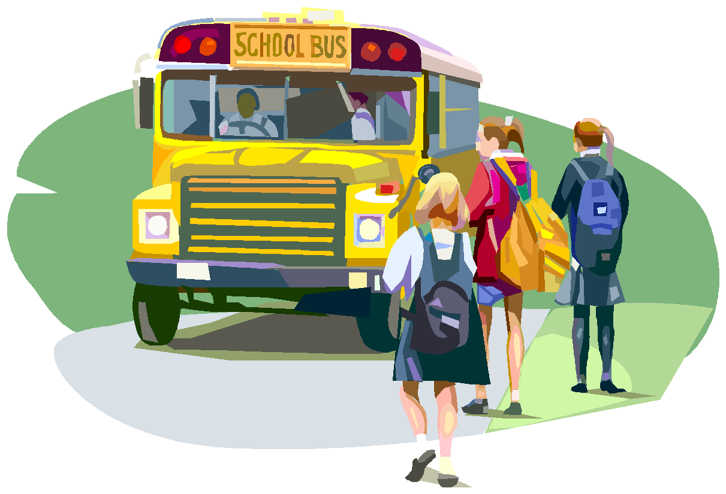
Bus Rules:
- Immediately follow the directions of the driver.
- Sit in your assigned seat facing forward.
- Talk quietly and use appropriate language.
- Keep all parts of your body inside the bus.
- Keep your arms, legs, and belongings to yourself.
- No fighting, harassment, intimidation, or horseplay.
- Do not throw any object.
- No eating, drinking, or use of tobacco or drugs.
- Do not bring any weapons or dangerous objects on the school bus.
10. Do not damage the school bus.

Consequences for Bus Violations:
- 1st Offense: Warning by the bus driver and call to parents/guardian
- 2nd Offense: 1 day suspension from the bus and call to parents/guardian
- 3rd Offense: 3 days suspension from the bus and call to parents/guardian
- 4th Offense: Any further consequences will be delivered from the school, in conjunction with the superintendent, who is the Director of Transportation, and/or the Principal. This may result in permanent removal from bus transportation.
*In-school consequences may also be a part of any disciplinary action.

COMMUNICATION:
Open communication between home and school is critical to your child’s success. Conferences, open houses, report cards, instant alerts, and newsletters are some of the formal ways we use to keep you informed about your child’s school experiences. Please keep us informed. A dated, signed note is required in the following circumstances:
- You want your child to stay in during recess, or to miss physical education class, which requires a doctor’s excuse.
- Your child will leave school early, or will leave and return during the day.
- A note must be brought into the office on Monday with your child’s weekly schedule. No changes will be allowed. Please speak with your child at home about their schedule. Please plan ahead. Do not call the school office asking to speak with your child unless it is a family emergency.

CONFERENCES AND REPORT CARDS:
Parent-teacher conferences are scheduled in the fall and spring. They provide a valuable opportunity for the parent/guardian and teacher to share information about the child. In addition, parents or teachers may request special conferences at any time of the year, if desired.

Report cards are issued four times a year at the end of each quarter.

DISCIPLINE:

We believe that all students can behave appropriately at school. In order to create an environment where learning can best take place, students are expected to conduct themselves in a safe and non-violent manner, respecting the rights of others. Behavior that disrupts the environment, infringes upon others, or creates unsafe conditions by a student while under school jurisdiction is not acceptable. The staff at our school has the goal of establishing an atmosphere in which children feel safe, secure, and happy, and in addition, have maximum opportunities to learn. Please notify the office at 246-8860 if you would like support for your student with behavioral or emotional concerns. King School works to ensure that ALL students are successful by promoting “King Pride” among the King School community. We ask students to show “King Pride” by:
Being Respectful, Being Responsible and Being Safe

SCHOOL BOARD POLICY GOVERNING STUDENT BEHAVIOR:

**Any student who disturbs or interrupts the peace and good order of the school or school-sponsored activities will be subject to disciplinary action, which may include suspension from school.

ASSAULT:

DANGEROUS THREATS
Threats to normal school operations or school activities, such as reporting of dangerous or hazardous situations that do not exist, are against school rules and state statute.

PHYSICAL ASSAULT (FIGHTING)
Physical assault is an act which intentionally inflicts, or attempts to inflict, bodily harm upon another.

Physical assault by students against staff members or students is considered to be a major violation and the principal or staff member must take immediate action to halt such behavior. In reacting to incidents of assault, staff members may be required to use reasonable physical force to prevent or minimize injury to students or staff.

SEXUAL, RELIGIOUS, RACIAL HARASSMENT OR VIOLENCE
It is the policy of Independent School District #317 to maintain learning and working environment that is free from religious, racial, or sexual harassment and violence. The school district prohibits any form of religious, racial, or sexual harassment and violence.

It shall be a violation of this policy for any pupil, teacher, administrator or other school personnel of the school district to harass a pupil, teacher, administrator, or other school personnel through conduct or communication of a sexual nature or regarding religion and race as defined by this policy. (For purposes of this policy school personnel includes; school board members, school employees, agents, volunteers, contractors, or persons subject to the supervision and control of the district.)

RACIAL HARASSMENT DEFINITION
Racial harassment consists of physical or verbal conduct relating to an individual’s race when the conduct:
1. Has the purpose or effect of creating an intimidating, hostile or offensive working or academic environment;
2. Has the purpose or effect of substantially or unreasonably interfering with an individual’s work or academic performance;
3. Otherwise adversely affects an individual’s employment or academic opportunities.

RACIAL VIOLENCE DEFINITION
Racial violence is a physical act of aggression or assault upon another because of, or in a manner reasonably related to, race.

RELIGIOUS HARASSMENT DEFINITION
Religious harassment consists of physical or verbal conduct which is related to an individual’s religion when the conduct:
- Has the purpose or effect of creating an intimidating, hostile, or offensive working or academic environment;
- Has the purpose or effect of substantially or unreasonably interfering with an individual’s work or academic performance;
- Otherwise adversely affects an individual’s employment or academic opportunities.

RELIGIOUS VIOLENCE DEFINITION
Religious violence is a physical act of aggression or assault upon another because of, or in a manner reasonably related to, religion.

SEXUAL HARASSMENT DEFINITION
Sexual harassment consists of unwelcome sexual advances, requests for sexual favors, sexually motivated physical conduct or other verbal or physical conduct or communication of a sexual nature when:
- submission to that conduct or communication is made a term or condition, either explicitly or implicitly, or obtaining or retaining employment, or of obtaining an education; or
- submission to or rejection of that conduct or communication by an individual is used as a factor in decisions affecting that individual’s employment or education; or
- that conduct or communication has the purpose or effect of substantially or unreasonably interfering with an individual’s employment or education, or creating an intimidating, hostile or offensive employment or educational environment.

Sexual harassment may include but is not limited to:
- unwelcome verbal harassment or abuse;
- unwelcome pressure for sexual activity;
- unwelcome, sexually motivated or inappropriate patting, pinching, or physical contact, other than necessary restraint of pupil(s) by teachers, administrators, or other school personnel to avoid physical harm to persons or property;
- unwelcome sexual behavior or words, including demands for sexual favors, accompanied by implied or overt threats concerning an individual’s employment or educational status;
- unwelcome sexual behavior or words, including demands for sexual favors, accompanied by implied or overt promised or preferential treatment with regard to an individual’s employment or educational status; or
- unwelcome behavior or words directed at an individual because of gender.

SEXUAL VIOLENCE DEFINITION
Sexual violence is a physical act of aggression or force or the threat thereof which involves the touching of another’s intimate parts, or forcing a person to touch any person’s intimate parts. Intimate parts, as defined in Minnesota Statutes Section 609.341, include the primary genital area, groin, inner thigh, buttocks, or breast, as well as the clothing covering these areas.

Sexual violence may include, but is not limited to:
1. touching, patting, grabbing, or pinching another person’s intimate parts, whether that person is of the same sex or of the opposite sex;
2. coercing, forcing or attempting to coerce or force the touching of anyone’s intimate parts;
3. coercing, forcing or attempting to coerce or force sexual intercourse or a sexual act on another; or
4. threatening to force or coerce sexual acts, including the touching of intimate parts or intercourse, on another.

BULLYING DEFINITION
1. Bullying is aggressive behavior that involves unwanted, negative actions.
2. Bullying involves a pattern of behavior repeated over time.
3. Bullying involves an imbalance of power or strength.

VERBAL ASSAULT
Abusive, threatening, profane, or obscene language either oral or gestures by a student towards a staff member or another student are forbidden.

THEFT
Theft is the act of intentionally and without claim of right taking, using, transferring, concealing, or retaining possession of movable property of another without consent and with intent to deprive the owner permanently of the property; or finding lost property and not having made reasonable effort to find the owner to return the property. Students guilty of theft will be subject to disciplinary action. Theft of personal or school property should be reported to the High School Office. Consequences are dependant upon theft of item.

Discipline Actions for Theft
1st Violation: Suspension, parent conference, referral to court, and/or restitution.
2nd Violation: Suspension, parent conference, referral to court, and/or restitution.
3rd Violation: Referral to an Alternative Program and restitution. Expulsion/Exclusion

CONTROLLED SUBSTANCES:

ALCOHOL
Students are prohibited from using, possessing, or being under the influence of alcoholic beverages at school, (including look-a-like products such as non alcoholic beer, wine, etc.) on school grounds, or at school-sponsored activities.

DRUGS
Students are prohibited from using, possessing, distributing or being under the influence of illegal drugs or narcotics at school, school-sponsored activities, or on school grounds.

USE OF TOBACCO PRODUCTS
Students are prohibited from using or possessing tobacco products in the school building, on school grounds, or at school- sponsored activities. This includes look-a-like products to include, but not limited to, tins or pouches.

DISCIPLINE ACTION FOR CHEMICAL USE OR POSSESSION BY

STUDENTS
When chemical use or possession is identified, the School District shall intervene. Intervening is directed at addressing chemical use problems in a way designed to correct and best facilitate resolution of the problem.

A school district employee who knows or has reason to believe that a student is using, possessing, or transferring alcohol or a controlled substance while on the school district premises or involved in school district-related activities shall immediately notify the school office.
I. Removal Procedures
A. When a student is in possession of a mood-altering chemical, the following steps are to be followed:
            - Search the student’s desk or book bag;
            - Contact parent/guardian and request they come to the school to meet with law enforcement. If parent/guardian is unavailable, the school will attempt to contact the person identified as the emergency contact person, unless the parent has informed the school not to, before law enforcement makes a determination about appropriate response.
            - Contact law enforcement for possible legal action and removal.
            - Students in possession of alcohol or other drugs in an amount indicating intention to sell or give away to others shall be subject to expulsion under the Minnesota Pupil Fair Dismissal Act of 1974.

B. When a student shows evidence of consumption, the following steps are to be followed:
1. Search the student’s desk or book bag
2. Contact parent/guardian and request they come to will attempt to contact the person identified as the emergency contact person, unless the parent has informed the school not to, before law enforcement will make a determination about appropriate response.
3. Contact law enforcement for possible legal action and removal.
4. Involve health service staff to check medical records for prescription or other medical situations.

II. Consequences

First Violation
1. The student will be suspended from classes for three school days according to the Minnesota Pupil Fair Dismissal Act of 1974. The student’s readmission plan shall include a professional chemical use assessment prior to readmission to school. The recommendations resulting from the chemical use assessment shall be followed for continued enrollment in school.

Second Violation
1. The student will be suspended from classes for five school days according to the Minnesota Pupil Fair dismissal Act of 1974. The student’s readmission plan shall include a professional chemical use assessment prior to readmission to school. The recommendations resulting from the chemical use assessment shall be followed for continued enrollment in county-wide schools.

Third or Subsequent Violations
1. The student will be suspended pending further disciplinary action for repeated disregard of school rules, state laws, being a danger to self or others, and/or being disruptive to the school environment. Possible action includes indicated treatment, homebound instruction or expulsion for the balance of the school year under the Minnesota Pupil Fair Dismissal Act of 1974.

Violations of the mood-altering chemicals policy are cumulative for K-12.

It is the position of the School Board of Independent School District #317 that learning can best take place in an orderly environment and that students can best learn individual and collective responsibility and gain maturity if they are provided opportunities in which to exercise responsibility within the school setting.

The school board believes in protecting the rights of all students. A consistent, continuous program dealing with the rights of people and a respect for individual differences must permeate the entire educational system. Students need to be taught the seriousness of actions which are degrading or hostile to other individuals and groups. The staff has the responsibility to define and the authority to respond to intolerant behavior, such as racial, sexist, or ethnic slurs, verbal assaults, physical assaults, or any actions considered demeaning to others.

It is the responsibility of the school board, administrators, and teachers to safeguard the health and safety of each student. The school and district administrators will support district personnel who, in dealing with students on disciplinary matters, act in accordance with state law, State Board of Regulations, and this policy.

The school board recognizes its responsibility to meet the educational needs of students who do not respond well to normal school procedures. If a student does not respond to these efforts and consistently exerts a disruptive influence on the educational environment of a school, the needs of the other students and staff must become a major factor in planning alternatives.

With due consideration given to these obligations, it is the responsibility of the school, administrators, and classroom teachers to make reasonable rules and regulations for governing student behavior and conduct.

WEAPONS POLICY
No student shall possess, use or distribute a weapon when in a school building, on school grounds, or on any school-sponsored trip or activity. A “weapon” means any object, device or instrument designed as a weapon or through its use is capable of threatening or producing bodily harm or may be used to inflict self injury including, but not limited to, any firearm, whether loaded or unloaded: air guns, pellet guns, BB guns, knives, blades, clubs, metal knuckles, nunchucks, throwing stars, explosives, fireworks, mace and other propellants, stun guns, ammunition, poisons, chains, arrows, and objects that have been modified to serve as a weapon.

No student shall possess, use or distribute any object, device or instrument having the appearance of a weapon and such objects, devices or instruments shall be treated as weapons including, but not limited to, weapons listed above which are broken or non-functional, look-alike guns, toy guns, and any object that is a facsimile of a real weapon.

A student who finds a weapon on the way to school or in the school building and takes the weapon immediately to the principal’s office shall not be considered to possess a weapon.

No student shall use articles designed for other purposes (i.e. belts, combs, pencils, files, scissors, etc.) to inflict bodily harm and/or intimidate. Such use will be treated as the possession and use of a weapon.

The school district and the school take a position of “Zero Tolerance” in regards to the possession, use or distribution of weapons by students. Consequently, the minimum consequence for students possessing, using or distributing weapons shall include an initial out-of-school suspension for four (4) days, confiscation of the weapon, notification of police, parent notification and recommendation of expulsion to the Superintendent of Schools.

While the school district and the school takes a firm “Zero Tolerance” position of the possession, use or distribution of weapons by students, such a position is not meant to interfere with the instruction or use of appropriate equipment and tools by students. Such equipment and tools, when properly used and stored, shall not be considered a violation of the rule against the possession, use or distribution of weapons by students. However, when authorized instructional and work equipment and tools are used in a potentially dangerous or threatening manner, such possession and use will be treated as the possession and use of a weapon.

While the school district and the school takes a “Zero Tolerance” position on the possession, use or distribution of weapons by students, there could be a very rare occasion when a weapon is inadvertently brought onto school property. If such an occasion is clearly the case, the principal, after a thorough investigation, may use discretion in determining whether, under the circumstances, a course of action other than an automatic recommendation for expulsion is warranted. If so, other appropriate action may be taken, including a recommendation for expulsion for less than the full school year.

BULLYING PROHIBITION POLICY

I. PURPOSE

A safe and civil environment is needed for students to learn and attain high academic standards and to promote healthy human relationships. Bullying, like other violent or disruptive behavior, is conduct that interferes with students’ ability to learn and teachers’ ability to educate students in a safe environment. The school district cannot monitor the activities of students at all times and eliminate all incidents of bullying between students, particularly when students are not under the direct supervision of school personnel. However, to the extent such conduct affects the educational environment of the school district and the rights and welfare of its students and is within the control of the school district in its normal operations, it is the school district’s intent to prevent bullying and to take action to investigate, respond, remediate, and discipline those acts of bullying which have not been successfully prevented. The purpose of this policy is to assist the school district in its goal of preventing and responding to acts of bullying, intimidation, violence, and other similar disruptive behavior.

II. GENERAL STATEMENT OF POLICY
A. An act of bullying, by either an individual student or a group of students, is expressly prohibited on school premises, on school district property, at school functions or activities, or on school transportation. This policy applies not only to students who directly engage in an act of bullying but also to students who, by their indirect behavior, condone or support another student’s act of bullying. This policy also applies to any student whose conduct at any time or in any place constitutes bullying or other prohibited conduct that interferes with or obstructs the mission or operations of the school district or the safety or welfare of the student or other students, or materially and substantially interferes with a student’s educational opportunities or performance or ability to participate in school functions or activities or receive school benefits, services, or privileges. This policy also applies to an act of cyberbullying regardless of whether such act is committed on or off school district property and/or with or without the use of school district resources.

B. No teacher, administrator, volunteer, contractor, or other employee of the school district shall permit, condone, or tolerate bullying.

C. Apparent permission or consent by a student being bullied does not lessen or negate the prohibitions contained in this policy.

D. Retaliation against a victim, good faith reporter, or a witness of bullying is prohibited.

E. False accusations or reports of bullying against another student are prohibited.

F. A person who engages in an act of bullying, reprisal, retaliation, or false reporting of bullying or permits, condones, or tolerates bullying shall be subject to discipline or other remedial responses for that act in accordance with the school district’s policies and procedures, including the school district’s discipline policy (See MSBA/MASA Model Policy 506). The school district may take into account the following factors:

1. The developmental ages and maturity levels of the parties involved;

2. The levels of harm, surrounding circumstances, and nature of the behavior;

3. Past incidences or past or continuing patterns of behavior;

4. The relationship between the parties involved; and

5. The context in which the alleged incidents occurred.

Consequences for students who commit prohibited acts of bullying may range from remedial responses or positive behavioral interventions up to and including suspension and/or expulsion. The school district shall employ research-based developmentally appropriate best practices that include preventative and remedial measures and effective discipline for deterring violations of this policy, apply throughout the school district, and foster student, parent, and community participation.

Consequences for employees who permit, condone, or tolerate bullying or engage in an act of reprisal or intentional false reporting of bullying may result in disciplinary action up to and including termination or discharge.

Consequences for other individuals engaging in prohibited acts of bullying may include, but not be limited to, exclusion from school district property and events.

G. The school district will act to investigate all complaints of bullying reported to the school district and will discipline or take appropriate action against any student, teacher, administrator, volunteer, contractor, or other employee of the school district who is found to have violated this policy.

III. DEFINITIONS

For purposes of this policy, the definitions included in this section apply.

A. “Bullying” means intimidating, threatening, abusive, or harming conduct that is objectively offensive and:

1. an actual or perceived imbalance of power exists between the student engaging in the prohibited conduct and the target of the prohibited conduct, and the conduct is repeated or forms a pattern; or

2. materially and substantially interferes with a student’s educational opportunities or performance or ability to participate in school functions or activities or receive school benefits, services, or privileges.

The term, “bullying,” specifically includes cyberbullying as defined in this policy.

B. “Cyberbullying” means bullying using technology or other electronic communication, including, but not limited to, a transfer of a sign, signal, writing, image, sound, or data, including a post on a social network Internet website or forum, transmitted through a computer, cell phone, or other electronic device. The term applies to prohibited conduct which occurs on school premises, on school district property, at school functions or activities, on school transportation, or on school computers, networks, forums, and mailing lists, or off school premises to the extent that it substantially and materially disrupts student learning or the school environment.

C. “Immediately” means as soon as possible but in no event longer than 24 hours.

D. “Intimidating, threatening, abusive, or harming conduct” means, but is not limited to, conduct that does the following:

1. Causes physical harm to a student or a student’s property or causes a student to be in reasonable fear of harm to person or property;

2. Under Minnesota common law, violates a student’s reasonable expectation of privacy, defames a student, or constitutes intentional infliction of emotional distress against a student; or

3. Is directed at any student or students, including those based on a person’s actual or perceived race, ethnicity, color, creed, religion, national origin, immigration status, sex, marital status, familial status, socioeconomic status, physical appearance, sexual orientation including gender identity and expression, academic status related to student performance, disability, or status with regard to public assistance, age, or any additional characteristic defined in the Minnesota Human Rights Act (MHRA). However, prohibited conduct need not be based on any particular characteristic defined in this paragraph or the MHRA.

E. “On school premises, on school district property, at school functions or activities, or on school transportation” means all school district buildings, school grounds, and school property or property immediately adjacent to school grounds, school bus stops, school buses, school vehicles, school contracted vehicles, or any other vehicles approved for school district purposes, the area of entrance or departure from school grounds, premises, or events, and all school-related functions, school-sponsored activities, events, or trips. School district property also may mean a student’s walking route to or from school for purposes of attending school or school-related functions, activities, or events. While prohibiting bullying at these locations and events, the school district does not represent that it will provide supervision or assume liability at these locations and events.

F. “Prohibited conduct” means bullying or cyberbullying as defined in this policy or retaliation or reprisal for asserting, alleging, reporting, or providing information about such conduct or knowingly making a false report about bullying.

G. “Remedial response” means a measure to stop and correct prohibited conduct, prevent prohibited conduct from recurring, and protect, support, and intervene on behalf of a student who is the target or victim of prohibited conduct.

H. “Student” means a student enrolled in a public school or a charter school.

IV. REPORTING PROCEDURE

A. Any person who believes he or she has been the target or victim of bullying or any person with knowledge or belief of conduct that may constitute bullying or prohibited conduct under this policy shall report the alleged acts immediately to an appropriate school district official designated by this policy. A person may report bullying anonymously. However, the school district may not rely solely on an anonymous report to determine discipline or other remedial responses.

B. The school district encourages the reporting party or complainant to use the report form available from the principal or building supervisor of each building or available in the school district office, but oral reports shall be considered complaints as well.

C. The building principal, the principal’s designee, or the building supervisor (hereinafter the “building report taker”) is the person responsible for receiving reports of bullying or other prohibited conduct at the building level. Any person may report bullying or other prohibited conduct directly to a school district human rights officer or the superintendent. If the complaint involves the building report taker, the complaint shall be made or filed directly with the superintendent or the school district human rights officer by the reporting party or complainant.

The building report taker shall ensure that this policy and its procedures, practices, consequences, and sanctions are fairly and fully implemented and shall serve as the primary contact on policy and procedural matters. The building report taker or a third party designated by the school district shall be responsible for the investigation. The building report taker shall provide information about available community resources to the target or victim of the bullying or other prohibited conduct, the perpetrator, and other affected individuals as appropriate.

D. A teacher, school administrator, volunteer, contractor, or other school employee shall be particularly alert to possible situations, circumstances, or events that might include bullying. Any such person who witnesses, observes, receives a report of, or has other knowledge or belief of conduct that may constitute bullying or other prohibited conduct shall make reasonable efforts to address and resolve the bullying or prohibited conduct and shall inform the building report taker immediately. School district personnel who fail to inform the building report taker of conduct that may constitute bullying or other prohibited conduct or who fail to make reasonable efforts to address and resolve the bullying or prohibited conduct in a timely manner may be subject to disciplinary action.

E. Reports of bullying or other prohibited conduct are classified as private educational and/or personnel data and/or confidential investigative data and will not be disclosed except as permitted by law. The building report taker, in conjunction with the responsible authority, shall be responsible for keeping and regulating access to any report of bullying and the record of any resulting investigation.

F. Submission of a good faith complaint or report of bullying or other prohibited conduct will not affect the complainant’s or reporter’s future employment, grades, work assignments, or educational or work environment.

G. The school district will respect the privacy of the complainant(s), the individual(s) against whom the complaint is filed, and the witnesses as much as possible, consistent with the school district’s obligation to investigate, take appropriate action, and comply with any legal disclosure obligations.

V. SCHOOL DISTRICT ACTION

A. Within three days of the receipt of a complaint or report of bullying or other prohibited conduct, the school district shall undertake or authorize an investigation by the building report taker or a third party designated by the school district.

B. The building report taker or other appropriate school district officials may take immediate steps, at their discretion, to protect the target or victim of the bullying or other prohibited conduct, the complainant, the reporter, and students or others, pending completion of an investigation of the bullying or other prohibited conduct, consistent with applicable law.

C. The alleged perpetrator of the bullying or other prohibited conduct shall be allowed the opportunity to present a defense during the investigation or prior to the imposition of discipline or other remedial responses.

D. Upon completion of an investigation that determines that bullying or other prohibited conduct has occurred, the school district will take appropriate action. Such action may include, but is not limited to, warning, suspension, exclusion, expulsion, transfer, remediation, termination, or discharge. Disciplinary consequences will be sufficiently severe to try to deter violations and to appropriately discipline prohibited conduct. Remedial responses to the bullying or other prohibited conduct shall be tailored to the particular incident and nature of the conduct and shall take into account the factors specified in Section II.F. of this policy. School district action taken for violation of this policy will be consistent with the requirements of applicable collective bargaining agreements; applicable statutory authority, including the Minnesota Pupil Fair Dismissal Act; the student discipline policy (See MSBA/MASA Model Policy 506) and other applicable school district policies; and applicable regulations.

E. The school district is not authorized to disclose to a victim private educational or personnel data regarding an alleged perpetrator who is a student or employee of the school district. School officials will notify the parent(s) or guardian(s) of students who are targets of bullying or other prohibited conduct and the parent(s) or guardian(s) of alleged perpetrators of bullying or other prohibited conduct who have been involved in a reported and confirmed bullying incident of the remedial or disciplinary action taken, to the extent permitted by law.

F. In order to prevent or respond to bullying or other prohibited conduct committed by or directed against a child with a disability, the school district shall, when determined appropriate by the child’s individualized education program (IEP) team or Section 504 team, allow the child’s IEP or Section 504 plan to be drafted to address the skills and proficiencies the child needs as a result of the child’s disability to allow the child to respond to or not to engage in bullying or other prohibited conduct.

VI. RETALIATION OR REPRISAL

The school district will discipline or take appropriate action against any student, teacher, administrator, volunteer, contractor, or other employee of the school district who commits an act of reprisal or who retaliates against any person who asserts, alleges, or makes a good faith report of alleged bullying or prohibited conduct, who provides information about bullying or prohibited conduct, who testifies, assists, or participates in an investigation of alleged bullying or prohibited conduct, or who testifies, assists, or participates in a proceeding or hearing relating to such bullying or prohibited conduct. Retaliation includes, but is not limited to, any form of intimidation, reprisal, harassment, or intentional disparate treatment. Disciplinary consequences will be sufficiently severe to deter violations and to appropriately discipline the individual(s) who engaged in the prohibited conduct. Remedial responses to the prohibited conduct shall be tailored to the particular incident and nature of the conduct and shall take into account the factors specified in Section II.F. of this policy.

VII. TRAINING AND EDUCATION

A. The school district shall discuss this policy with school personnel and volunteers and provide appropriate training to school district personnel regarding this policy. The school district shall establish a training cycle for school personnel to occur during a period not to exceed every three school years. Newly employed school personnel must receive the training within the first year of their employment with the school district. The school district or a school administrator may accelerate the training cycle or provide additional training based on a particular need or circumstance. This policy shall be included in employee handbooks, training materials, and publications on school rules, procedures, and standards of conduct, which materials shall also be used to publicize this policy.

B. The school district shall require ongoing professional development, consistent with Minn. Stat. § 122A.60, to build the skills of all school personnel who regularly interact with students to identify, prevent, and appropriately address bullying and other prohibited conduct. Such professional development includes, but is not limited to, the following:

1. Developmentally appropriate strategies both to prevent and to immediately and effectively intervene to stop prohibited conduct;

2. The complex dynamics affecting a perpetrator, target, and witnesses to prohibited conduct;

3. Research on prohibited conduct, including specific categories of students at risk for perpetrating or being the target or victim of bullying or other prohibited conduct in school;

4. The incidence and nature of cyberbullying; and

5. Internet safety and cyberbullying.

C. The school district annually will provide education and information to students regarding bullying, including information regarding this school district policy prohibiting bullying, the harmful effects of bullying, and other applicable initiatives to prevent bullying and other prohibited conduct.

D. The administration of the school district is directed to implement programs and other initiatives to prevent bullying, to respond to bullying in a manner that does not stigmatize the target or victim, and to make resources or referrals to resources available to targets or victims of bullying.

E. The administration is encouraged to provide developmentally appropriate instruction and is directed to review programmatic instruction to determine if adjustments are necessary to help students identify and prevent or reduce bullying and other prohibited conduct, to value diversity in school and society, to develop and improve students’ knowledge and skills for solving problems, managing conflict, engaging in civil discourse, and recognizing, responding to, and reporting bullying or other prohibited conduct, and to make effective prevention and intervention programs available to students.

The administration must establish strategies for creating a positive school climate and use evidence-based social-emotional learning to prevent and reduce discrimination and other improper conduct.

The administration is encouraged, to the extent practicable, to take such actions as it may deem appropriate to accomplish the following:

1. Engage all students in creating a safe and supportive school environment;

2. Partner with parents and other community members to develop and implement prevention and intervention programs;

3. Engage all students and adults in integrating education, intervention, and other remedial responses into the school environment;

4. Train student bystanders to intervene in and report incidents of bullying and other prohibited conduct to the school’s primary contact person;

5. Teach students to advocate for themselves and others;

6. Prevent inappropriate referrals to special education of students who may engage in bullying or other prohibited conduct; and

7. Foster student collaborations that, in turn, foster a safe and supportive school climate.

F. The school district may implement violence prevention and character development education programs to prevent or reduce policy violations. Such programs may offer instruction on character education including, but not limited to, character qualities such as attentiveness, truthfulness, respect for authority, diligence, gratefulness, self-discipline, patience, forgiveness, respect for others, peacemaking, and resourcefulness.

G. The school district shall inform affected students and their parents of rights they may have under state and federal data practices laws to obtain access to data related to an incident and their right to contest the accuracy or completeness of the data. The school district may accomplish this requirement by inclusion of all or applicable parts of its protection and privacy of pupil records policy (See MSBA/MASA Model Policy 515) in the student handbook.

VIII. NOTICE

A. The school district will give annual notice of this policy to students, parents or guardians, and
staff, and this policy shall appear in the student handbook.

B. This policy or a summary thereof must be conspicuously posted in the administrative offices of the school district and the office of each school.

C. This policy must be given to each school employee and independent contractor who regularly interacts with students at the time of initial employment with the school district.

D. Notice of the rights and responsibilities of students and their parents under this policy must be included in the student discipline policy (See MSBA/MASA Model Policy 506) distributed to parents at the beginning of each school year.

E. This policy shall be available to all parents and other school community members in an electronic format in the language appearing on the school district’s or a school’s website.

F. The school district shall provide an electronic copy of its most recently amended policy to the Commissioner of Education.

IX. POLICY REVIEW

To the extent practicable, the school board shall, on a cycle consistent with other school district policies, review and revise this policy. The policy shall be made consistent with Minn. Stat. § 121A.031 and other applicable law. Revisions shall be made in consultation with students, parents, and community organizations.

DRESS CODE:
Although we do not have a formal dress code, we need parental support in having children cooperate with the requests and positions we have taken as explained below:

- Hats should never be worn in a public building, except for special occasions. Hats must be worn appropriately.
- Proper shoes must be worn at all times. Tennis shoes must be worn for physical education.
- During the winter months, when the temperature/wind chill is above -8 degrees, recess will remain outdoors. If the temperature is 32 degrees or below, the students are to wear the following:
  - Winter coats
  - Boots
  - Hats
  - Mittens
  - Snow pants
- Students may be asked to wear snow pants in the spring to protect clothing.
If the temperature, with wind chill, is below –8 degrees, the office will announce that recess will be held inside.

Clothing should not be so extreme or so inappropriate to the school setting as to disrupt the educational process.
Clothing deemed distracting is not permitted. This includes bare stomachs or backs, spaghetti straps, muscle shirts, halter tops, short shorts, and extremely short dresses or skirts.
- NO inappropriate wording, symbols, or language will be permitted on clothing worn to school. (This includes T-shirts with questionable or double-meaning messages.)
- We do not find the following clothing items suitable for elementary school students due to health, safety, and gang-related issues:
  - No long belts
  - No excessively low-riding, baggy pants
  - No hats, caps, or hoods worn in school.
  - No bib overalls with straps hanging loose
  - No body drawing/art
  - No bandanas
  - No gang affiliated colors
  - No heavy fragrances
If a student fails to comply with these codes, the student will be required to immediately remedy the infraction, with the guidance of an adult.

GYM SHOES:
Rubber soled leather or canvas gym tennis shoes must be worn in the gymnasium and are required of all children. This is in the interest of both health and safety. They should be labeled with the child’s name and should only be worn for physical education classes, if possible.

EMERGENCY PHONE NUMBER:
We must have on file the name, address and phone number of a relative or friend in case we cannot reach you in an emergency. If you have a regular schedule of activities, such as sports or volunteer work, please let us know your schedule and the phone numbers where you can be reached.

It is essential that this record be kept current. Please notify the office if there are changes or additions during the year.

EMERGENCY SCHOOL CLOSINGS:
In the event of weather related school closings, tune in to KOZY, KMFY, KGPZ, WNMT, KAXE, WUSZ, KMFG, KQDS, tv channel 3/11 KDLH, channel 10/13 WDIO/WIRT, channel 21 KQDS, channel 6 KBJR, channel 4 WCCO, channel 5 KSTP, and channel 9 KMSP early in the morning to find out the specifics. Should school be closed during the school day, please have a prearranged plan developed with a neighbor or relative that your child can follow. This helps to prevent unnecessary last minute phone calls. The school website www.isd317.org , parent portal, and instant alert may also provide information when it is necessary to close school.

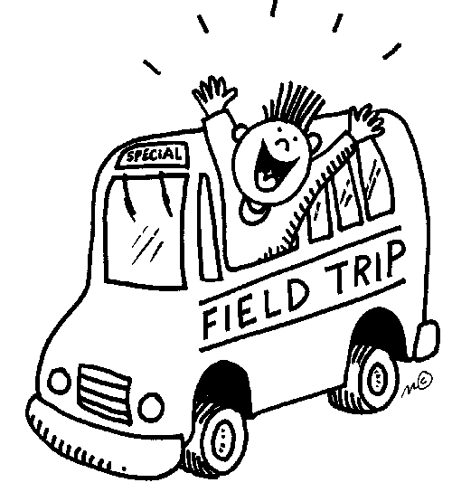
FIELD TRIPS:
Educational field trips may be taken by classes during the school year under the teacher’s direction. Parents may be asked to assist with these field trips. When trips are made in school buses outside school district boundaries, parents will be notified. Students may be asked to pay for a portion of the field trip costs. A permission slip is sent home in your child’s first Tuesday folder permitting their attendance at all field trips. All students attending the school led field trip must ride the specified transportation set up by the school. If the parent/guardian decides that their child will not ride the bus, the child will not be allowed to attend the school function and will be marked absent for the day.

HEALTH ISSUES:

Emergency Information:
Every child enrolled at King Elementary must have updated emergency information on file. This is our first reference in case we need to contact you regarding your child. If information changes during the school year, for example, the telephone numbers or place of employment, please inform the school office.

HEALTH PROBLEMS:
Please alert the school nurse and teacher if your child has a health problem that may affect the child’s functioning at school. This may include chronic health problems such as diabetes, asthma, or epilepsy.

Also, promptly report to the nurse any communicable diseases such as strep throat, chicken pox, scabies, or head lice. This information will be kept confidential.

HEALTH RECORDS:
A health record is kept for each child by the nurse. This is required by State Law. Any disease or immunization that the child has had during the summer or school year should be reported to the nurse so the information can be recorded on the child’s health records. The school nurse serves as a general health consultant and may be available to instruct health mini-units or lessons.

FOOD ALLERGIES:
Please alert the school nurse and teacher if your child has a food allergy. A doctor’s note is required if your child must be given a substitute food in the school lunchroom to avoid an allergic reaction.

HEALTH SCREENINGS:
Each fall, students are screened for vision and hearing problems. All students in grades K-5 have a yearly growth assessment. Referrals for medical evaluation are made if necessary.

IMMUNIZATIONS AND PHYSICAL EXAMINATIONS:
District 317 recommends physical examinations for elementary students prior to kindergarten and fourth grade. Forms are available from the health office.

Minnesota law requires that every child entering school must show evidence of adequate immunizations. This includes five doses of DPT (diphtheria, tetanus, and pertussis); four doses of polio; three doses of HBV (Hepatitis B), two doses of MMR (measles, mumps, and rubella), and two doses of chickenpox vaccine. If your child is not properly immunized, you will be notified by the nurse.

MEDICATION POLICY:
Medication schedules for students should be adjusted around school hours so that students will not need to take medications while at school. When it is absolutely necessary for medications to be administered during school hours, the medication must be in its prescription container, accompanied by a medication consent form from the doctor stating the type, dose, time, reason and effects of the medication.

On the rare occasion that over-the-counter medication (such as Tylenol) must be administered to a student, parent’s/guardian’s permission must be obtained. All medication (unless otherwise arranged) must be kept at the school office. Please inform the teacher and school nurse about any medication taken at home that may affect your child’s attention or behavior at school. If an over-the counter medication is to be used for more than a single dose, the medicine must be supplied by the parent, accompanied by a note from the child’s doctor stating the type, dose frequency, reason and effects of the medication.

STUDENT ILLNESS & ACCIDENTS:
Although regular attendance at school is of the utmost importance, we suggest that you do not send your child to school if they show signs of the following:
*Fever: Do not attend school if fever is above 100 degrees F orally, before fever reducing medications.
*Diarrhea: Do not attend school until diarrhea stops or medical exam indicates that it is not communicable.
*Vomiting: Do not attend school until no vomiting has occurred for at least 24 hours.
*Rash with fever: Do not attend school until healthcare provider indicates that it is not communicable.
*Eye drainage: Do not attend school until 24 hours after treatment of a purulent (pus) drainage. (No exclusion is needed for clear, watery drainage.)
*Strep throat: Do not attend school until 24 hours of antibiotic treatment.

If your child gets sick during school, the teacher, the school nurse, or other personnel will attempt to comfort your child or contact you (the parent), or the person you have designated on your child’s emergency contact.

Children who are injured during the school day are taken to the office or school nurse. If they feel that it is an emergency, parents are notified so that necessary action can be taken.

PETS:
If your child wishes to bring a pet for a visit, it must be cleared through your child’s teacher. Please try to avoid times when classes are changing and the hallways are congested.

FOOD TREATS:
In accordance with the Minnesota Health Department, if children bring treats to share, the treats must be purchased from a licensed store or baker. DO NOT bring treats prepared at home, as all food treats must display a list of ingredients.

INSURANCE:
Information regarding health insurance is sent home to the parents at the beginning of the school year. Purchase of insurance is optional.

LIBRARY BOOKS/ClASSROOM LIBRARY BOOKS:
Our library is a vital part of our students’ education. Students have the opportunity to check out books each week. Your help in locating the books at home each week is requested. Students are responsible for the books assigned to them, regardless of the circumstances regarding the damage. In order to help us provide a great library for all students, students will be charged $15 for lost or damaged library books. All classroom books are furnished to the children. Students are responsible for the care and maintenance of these books. Parents can help a great deal in the care of the books (library books included) when children have them at home. It is highly recommended that your child be provided with a carrying bag to preserve the condition of the books and also to make it easier for them to carry. Students destroying school property will be asked to pay for destroyed property after reviewing the damage done.

Fines:
New Books
Lost – 75% of the original cost
Pages torn – 25% of the original cost
Broken binding – 50% of the original cost
Used Books
Lost – 50% of the original cost
Damaged – 25% of the original cost
No student will be denied educational activities (i.e. assignments, field trips, and assessments), grades, or promotion due to uncollected fines or fees.

LOST AND FOUND:
Parents should give the following suggestions careful consideration to help eliminate lost items:
- Clearly label your child’s coats, jackets, sweaters, caps, and boots with his/her name and grade.
- When an article is lost, don’t let time elapse before trying to locate it.
- Use caution in allowing articles of sentimental or monetary value to be brought to school.

PERSONAL PROPERTY AND MONEY HANDLING:
Children should not bring expensive jewelry, valuable toys, money, etc. to school. The use of cell phones and hand-held games are prohibited during school hours. These items must be kept in the student’s backpack or school bag. If it is necessary to send money to school, please put it in a sealed envelope with the child’s name, date, and purpose of the money written on the envelope. Lunch payments should be brought to the office before classes begin each morning. Checks for lunch money should be made out to ISD #317. It would be helpful if you could include the family’s lunch account number on the check.

PLEDGE OF ALLEGIANCE
Minnesota Statutes 121A.11: “Anyone who does not wish to participate in reciting the pledge of allegiance for any personal reasons may elect not to do so. Students must respect another person’s right to make that choice.”

Parents and Teachers of King School (PTKS) ACTIVITIES:
PTKS meetings are held monthly throughout the year. The PTKS organization sponsors or supports the following activities which take place in our school each year:

- Open House
- Fall Fundraiser
- Popcorn Wednesdays
- School Field Trips
- Care & Share Store
- King Fun Run

All of the fundraising efforts done throughout the year benefit all of our students by providing field trips at little to no cost to families. We encourage all parents to become involved with school events and PTKS activities throughout the year. Volunteers are always needed and appreciated. If you are interested in helping, please contact the elementary school office at 246-8860.

SCHOOL BOARD MEETINGS:
The ISD #317 School Board meets regularly on the first Monday of each month during the school year. The Board typically meets at King School or the High School. Normal meeting time is 6:00 p.m.

SCHOOL PROPERTY:
Students are responsible for the care and maintenance of the books, school supplies, and technology which are issued to them at the beginning of each school year. Students will be held responsible for any vandalism done to school property or to another student’s property. This behavior will result in a referral to the principal’s office. In the event that a school device is damaged by a student, charges may be issued to the student to repair or replace the device.

SPECIAL EDUCATION SERVICES:
Special Education is intended to meet the needs of identified students with disabilities whose needs are not met by regular education. Specifically, the learning of these students is significantly impacted by their disability. Federal and State laws specifically direct the eligibility and implementation of the services and programs. Special Education students are served in regular classrooms, special settings, or both, depending on team decisions based on student needs. If you have questions regarding special education programs, please contact the school principal.

PLAYGROUND RULES:

King School Playground
- Students will go down slides feet first.
- Students will refrain from climbing up the slides.
- Students will hang from monkey bars using only their hands.
- Students will refrain from jumping off any equipment.
- Students will only play inside safety railings
- Staff may choose to keep students off the equipment when it is wet or icy.

Swings:
- Students will refrain from jumping off swings.
- One student is permitted on a swing at a time.
- Students will refrain from standing on swings.
- Students will refrain from climbing up the supporting poles.
- Students will use the Zip Line one at a time.
Miscellaneous:
- Students will refrain from bringing electronics equipment outside. (i.e. iPods, phones, games, etc.).
- Students will refrain from playing tackle football.
- Students will refrain from jumping on other children’s backs, spitting, and swearing.
- Students who are placed at the wall must remain there until they are told to go.
- Under no circumstances are skateboards, snowboards or roller blades to be used at school.
- Students will refrain from playing murderball and/or dodgeball.
- Students will wear shoes at all times.
- Students will stay off the parking lot.
- No suckers or pop allowed on the playground.
- If popcorn comes outside, students may sit and eat it. Popcorn is not allowed on equipment.
- Students will refrain from throwing wood chips.
Snow:
- Students will leave snow on the ground while playing outside.
- Students will refrain from putting snow in other children’s faces, down their backs, etc.
- Students will refrain from playing “King of the Hill.”
- Students will refrain from playing on plowed up hills.
- Students MUST have boots and snow pants to slide down hill.
- Students will sit on their bottoms while going down the hill.

RETENTION AND PROMOTION POLICY
The promotion and retention of students must rely heavily on the professional judgment of the certified staff; however, parent input is both encouraged and expected. Accordingly, promotion and retention of students shall be evaluated according to documentation of the classroom teacher and other certified staff working with the student, i.e. grade level outcomes, classroom grade book, state performance standards, standardized test scores, Light’s Retention Scale, and social observations. Recommendations for retention will be based upon the following criteria:
- A student who is not sufficiently mature socially, emotionally, mentally, or physically, which interferes with school success.
- A student who has not reached a standard of achievement and/or proficiency in the three core areas (reading, mathematics, and written language) which would allow him/her to progress satisfactorily at the next grade level.
- A student who has not been in attendance for at least 155 days of the school year or has not met minimum standards as stated above.

Exceptions:
- A student will be retained only one time in any one grade level.
- A student will be retained no more than two total times in grades K-6.
- Students identified as eligible for special education shall be provided with appropriate programs to meet their needs. Promotion or retention of these students shall be on an individual basis with said results to be determined and approved by the Individual Educational Program Staffing Team.

The rights of parents to participate in decisions involving their children are also recognized. After a referral for retention is made, a conference will be scheduled. If the parents do not respond, they will be contacted by phone or mail on or before May 5. Parents shall be informed of the reasons for possible retention and the likely success of such retention. Should the parents not respond by May 20, a decision to retain or promote will be made by the certified school staff at that time. Parents must state specific reasons for their decisions for advancement or retention at a conference. Retention shall be used sparingly and only after all other opportunities for attaining acceptable achievement within the school have been offered.

STUDENT REGISTRATION:
Your child may enroll in kindergarten if he/she is five years old as of September 1 of the current school year. You will need to present a birth certificate and an updated immunization record at the time of registration.

Early childhood screening is also required for enrollment into Kindergarten or Head Start. Dates for early childhood screening are scheduled periodically throughout the school year. An appointment for screening of your preschool child can be made by contacting the school nurse at 246-8860 ext. 60412.

New students to our school should register at the office at the time of entry to school or prior to entry. The new student may attend school the day after they are registered at the office to allow time for the teacher/busing to prepare for the new student.

TITLE I PROGRAMS:

I. PURPOSE

The purpose of this policy is to encourage and facilitate parental participation in Title I LEA educational programs and experiences of students. The policy shall provide the framework for organized, systematic, ongoing, informed and timely parent involvement in relation to decisions about the Title I services within the school district. The involvement of parents by the Deer River elementary schools shall be directed toward both public and private school children whose parents are school district residents or whose children attend school within the boundaries of the school district.

II. GENERAL STATEMENT OF POLICY

- It is the policy of the Deer River elementary schools to plan and implement, with meaningful consultation with parents of participating children, programs, activities and procedures for the involvement of parents in its Title I programs.
- It is the policy of the Deer River elementary schools to fully comply with 20 U.S.C. 6319 which requires the school district to develop jointly with, agree upon with, and distribute to parents of children participating in Title I programs written parental involvement policies.

III. DEVELOPMENT OF DISTRICT LEVEL POLICY
The expectations for parent involvement are outlined below and also included in the Title I compact.
- Parents will be invited to participate in the planning/designing of the Title I plan and the process of school review and improvement;
- Title I meetings will be attended by the Title Administrator and members of the writing team in order to provide the coordination, technical assistance, and other support to assist schools in planning and implementing effective parental involvement;
- The elementary schools will plan a variety of activities that will build the schools’ and parents’ capacity for strong parent involvement;
- The elementary schools will coordinate and integrate parental involvement strategies with Head Start, ECFE, the Parents Organizations, area Day Cares, and State-run preschool programs;
- The elementary schools conduct a survey annually of parents for the purpose of an annual evaluation of the content and effectiveness of the parental involvement policy;
- The elementary schools will use the findings of the surveys to design strategies for improving and revising, if necessary, the district-level and school-level parental involvement policies;
- If the school district’s Title I plan is not satisfactory to the parents of participating children, the school district will submit any parent comments with the plan when the plan is submitted to the State.

DEVELOPMENT OF SCHOOL LEVEL POLICY
Each elementary school will distribute to parents of participating children a written parental involvement policy, agreed upon by such parents, that shall describe the means for carrying out the federal requirements of parental involvement.

- Each school with a Title I program will:
- Convene an annual review of the Title I plan at both the Open House in September and the regular school board meeting in September.
- The following activities will be held to facilitate parental involvement (purposely held at a variety of times): Open House, Bingo for Books, Conferences, Book Fairs, Family Literacy/Math nights, Kindergarten registration events, and additional activities as planned per grade level.
- Parents will be involved in the planning, review, and improvement of the parent involvement programs, including the school parental involvement policy and the joint development of the school wide program plan through parent organizations, surveys, and annual reviews in September.
- The elementary schools will provide parents of participating children with: timely information about Title I programs, school performance profiles as required by law, and their child’s individual student assessment results along with an interpretation of the results through conferences, Tuesday folders, and/or mailings. Additional conferences will be held upon parent or teacher request; Topics covered may include a description and explanation of the curriculum in use, the forms of assessment used, and the proficiency levels students are expected to meet. Additional opportunities to make suggestions, share experiences with other parents and participate in decisions relating to their child’s education can be honored through any of the activities/communications previously described within this policy;
- Parent comments from surveys or other communiqués will be used to inform the school-wide programs.

- As a component of this policy, the elementary schools have developed a school/parent compact which outlines how parents, staff, and students will share the responsibility for improved student achievement and attainment of State standards. The compacts will be sent home in the first Tuesday folder each fall.

- To ensure effective involvement of parents and to support a partnership among the school, parents, and community to improve student achievement:
- The elementary schools will provide assistance to participating parents in such areas as understanding Federal and State education goals, State content and student performance standards, assessments, monitoring their child’s progress, working with educators to improve their child’s performance, and participating in decisions regarding their child’s education through conferences, board meetings, parent meetings, Open House and upon parent request;
- Materials and training to assist parents in working with their children to improve their children’s achievement, including coordinating necessary literacy training will be offered through our Family Literacy program;
- Educating school staff, with the assistance of parents, in the value and contributions of parents and in how to reach out to, communicate with, and work with parents as equal partners, implement and coordinate parent programs, and build ties between home and school will be accomplished through six After School Specials held in Sep., Oct., Nov, Jan., Feb., Mar. each year;
- Efforts to coordinate and integrate parental involvement programs and activities with Head Start, Early Childhood programs, the Parent/ Teacher groups, and other programs, as is feasible and appropriate will continue;
- Ongoing efforts to develop appropriate roles for community-based organizations and businesses in parental involvement activities and providing information about and encouraging the formation of partnerships between public schools, businesses and parents will continue through Bingo for Books, Book Fairs, and Retired Seniors programs;
- Conducting activities such as parent resource centers and opportunities for parents to learn about child development and child rearing, as appropriate and feasible will occur through ECFE, EC, Family Literacy/Math Programs;
- Ensure, to the extent possible, that information about school and parent meetings, programs, and activities is sent home in the language used in the homes of the participating children through Tuesday folders;
- The elementary schools will provide other reasonable supports for parental involvement as requested by parents.

- To carry out the requirements of parental involvement, the school district and schools will provide full opportunities for the participation of parents with limited English proficiency or with disabilities, including providing information and school profiles in a language and form that is understandable by the parents.

- The school district and each school will assist parents and parent organizations in learning of and about parental information and resource centers.

The policies will be updated periodically to meet the changing needs of parents and the school.

KING PRIDE SONG
(To the tune of “You’re a Grand Ol’ Flag)

We’re a great grade school
Where all learning is cool
And forever we’ll show our King Pride
We’re respectful of
The school we love
With students and teachers side by side

All our days are filled,
We’re becoming more skilled
Thanks to all those who act as guide
Good citizens are growing here
SO LET’S ALL SHOW OUR KING PRIDE!!
YEAH!

